Student Performance and dropout risk Analysis using Python and Power BI
Project Title
Student Performance and dropout analysis using Python and Power BI
1. Introduction
This project presents a detailed analysis of student engagement and academic performance using Python and Power BI. The dataset was explored, cleaned, and analysed using Python libraries such as Pandas, Matplotlib, and Seaborn. After preprocessing and analysis, the dataset was imported into Power BI for interactive dashboard creation and visualization.
2. Objective
- To identify meaningful patterns, trends, and insights from student academic data using EDA.
- To clean, transform, and preprocess the dataset for better analysis.
- To create visualizations explaining student performance and dropout risk.
- To provide recommendations to improve pass rate and reduce dropout rate.
3. Domain
Education.
4. Dataset Information
Source: Kaggle / Open University Learning Analytics Dataset (OULAD style)
Timeline: Not specified in the dataset source
Dataset Size: 32593 Rows and 14 Columns
Description:
Column name | Description
Id _ student | Unique student id
gender | Student gender
Region | Student location (UK based)
Highest education | Qualification level
Studied credits | Credits enrolled
IM’d band | Economic background
Total clicks | Lms activity clicks
Avg score | Average score
Engagement level | Low /medium / high
Performance level | Academic performance
Risk level | Dropout risk
Pass flag | Pass=1, fail=0
Dropout flag | Dropout =1
Final result | Pass / fail /withdrawn

5. Type of Analysis
Descriptive Analysis – Summarizing the student dataset using measures such as average scores, total clicks, pass rates, and dropout counts.
Diagnostic Analysis – Identifying reasons behind student performance patterns, failures, and dropout risk based on engagement, education level, region, and credits studied.
Predictive Analysis – Estimating the likelihood of pass/fail or dropout risk using trends and student behaviour indicators.
Prescriptive Analysis – Providing recommendations to improve student performance, increase engagement, and reduce dropout rates.
6. Problem Definition
Business Problem:
Educational institutions often face challenges such as low student performance, poor engagement, and student dropouts. It is important to identify the factors affecting academic success and detect students who are at risk early.
Expected Outcome:
- Understand key factors influencing student performance.
- Identify students with high dropout risk.
- Improve engagement and pass rates through data-driven insights.
- Support better academic decision-making.

7. Pre-processing Techniques Used
a. Loading the Dataset
The dataset was loaded into Python using Pandas.
b. Understanding the Dataset
- Reviewed column names and data types
- Identified numerical and categorical variables
- Checked missing and duplicate values
- Verified score distributions and engagement patterns
c. Data cleaning
- Handled missing values using mode for categorical columns and using median for numerical columns.
- Identified and removed 1356 duplicate records to improve data quality.
- Detected and treated outliers in the total_ clicks column using the IQR method.
- Checked skewness and it had acceptable positive skewness, so no major transformation was required after outlier treatment.
- Verified data types of all columns and confirmed suitability for analysis.
- Created new features such as score_ category, engagement_ ratio, and click_ category.
d. Final validation
After cleaning, the size of dataset: 27395 rows and 17 columns.
8. Modelling
Data modelling and analysis were performed using Python and Power BI to generate meaningful insights.
8.1. Exploratory Data Analysis (EDA)
During exploration and analysis, multiple charts and reports were created using Python before finalizing the Power BI dashboard.
These include:
1.Histogram plot This chart shows distribution of student scores.
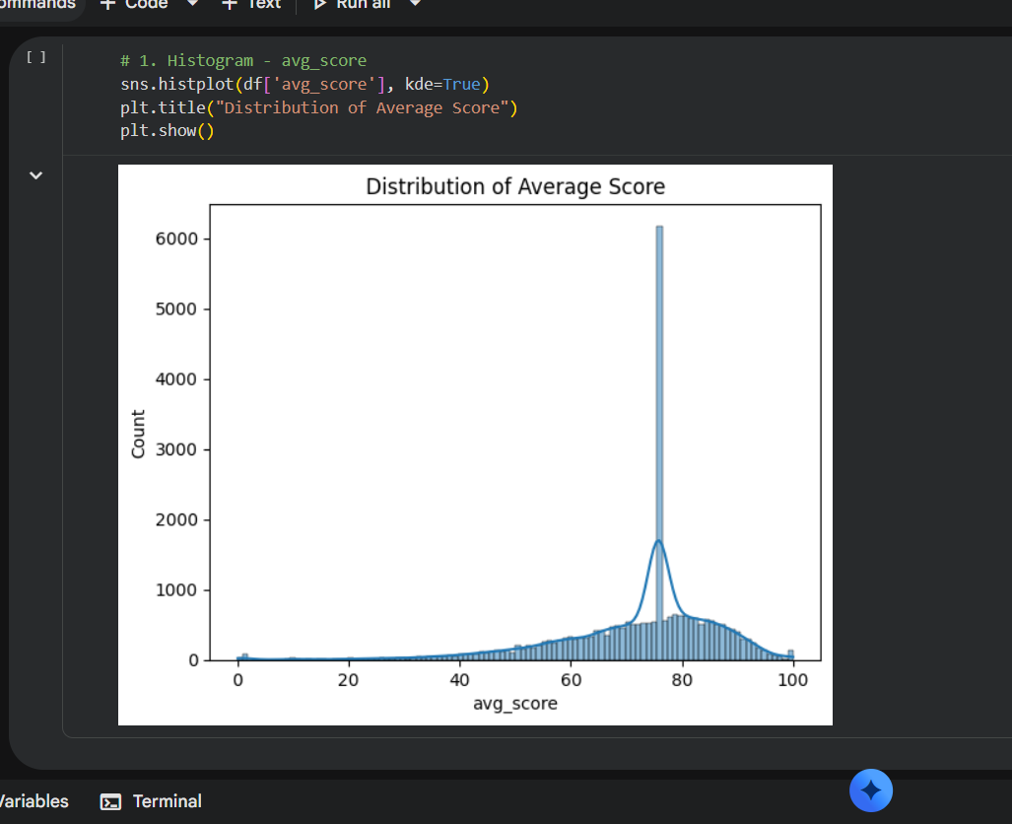
2. Scatter plot: This chart shows relationship between clicks and average _ score

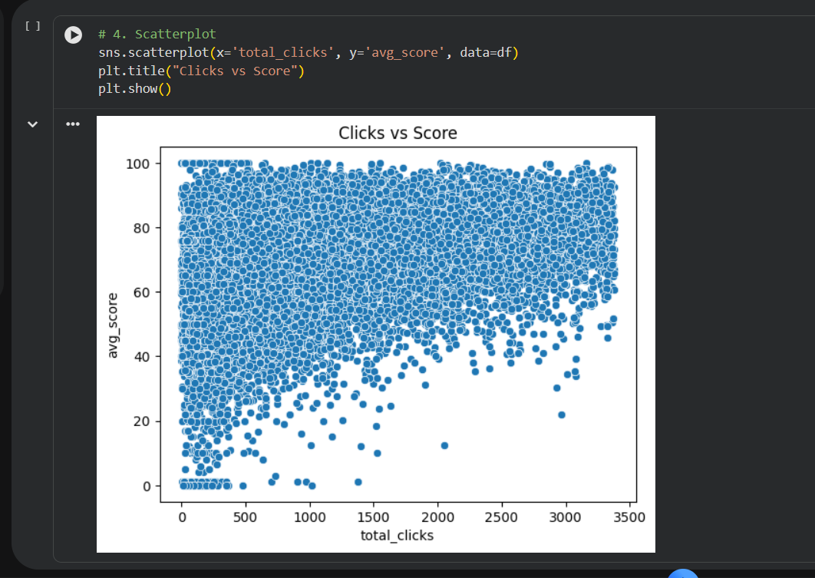
3. Box plot: This chart shows spread of clicks and identifies outliers
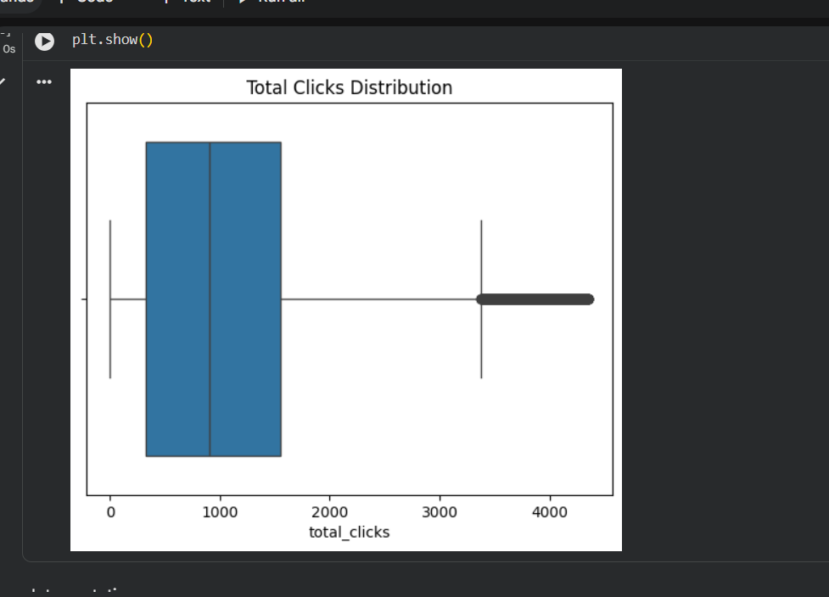
4. Heatmap: This chart shows correlation between numerical variables.

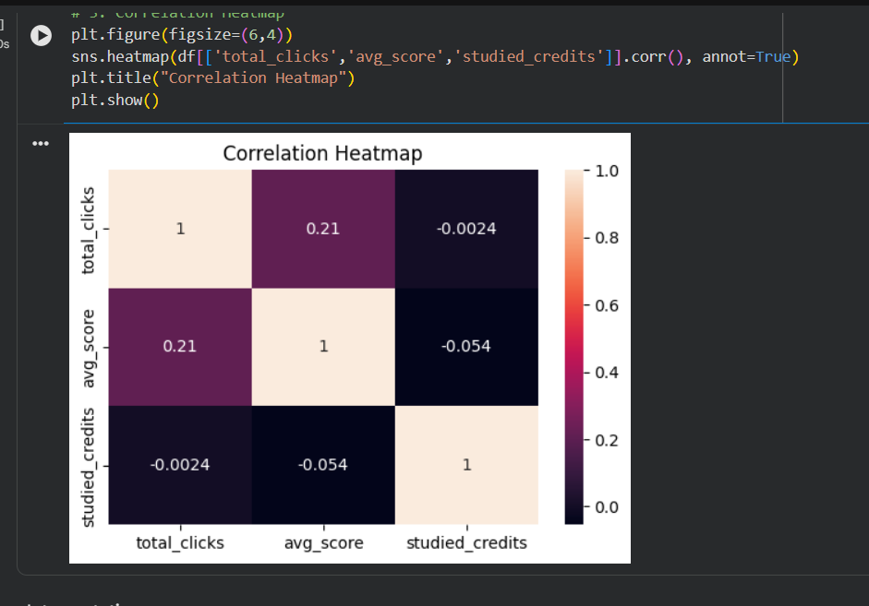

5. Violin plot: This violin plot shows the distribution and density of students average scores across different performance levels. 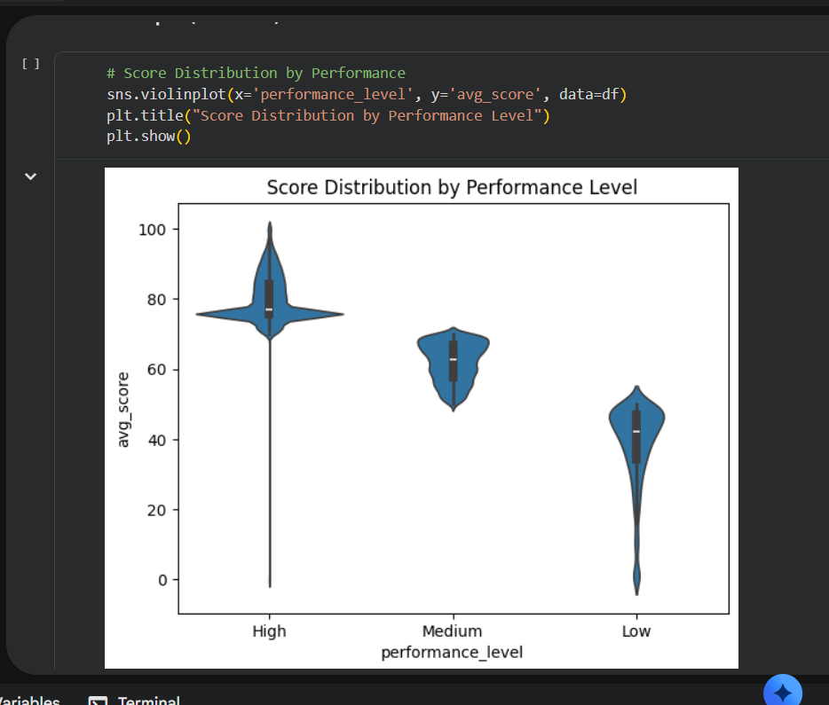
6. Bar chart: This chart shows the relationship between students' engagement level and their pass rate.
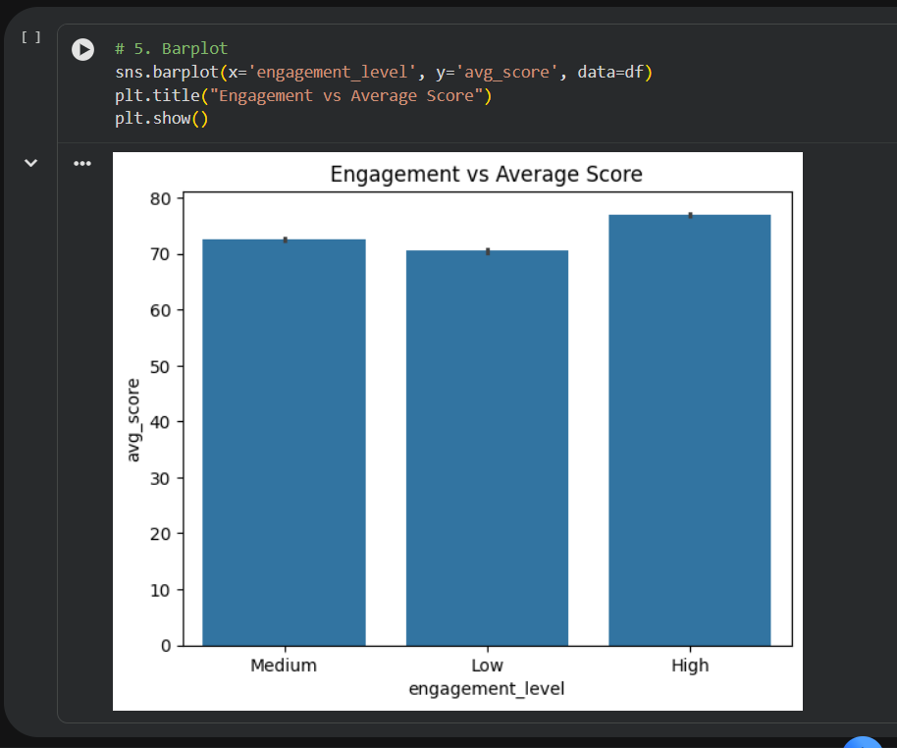
7.Pair plot: It is a pair plot used to show relationship between multiple numerical features. 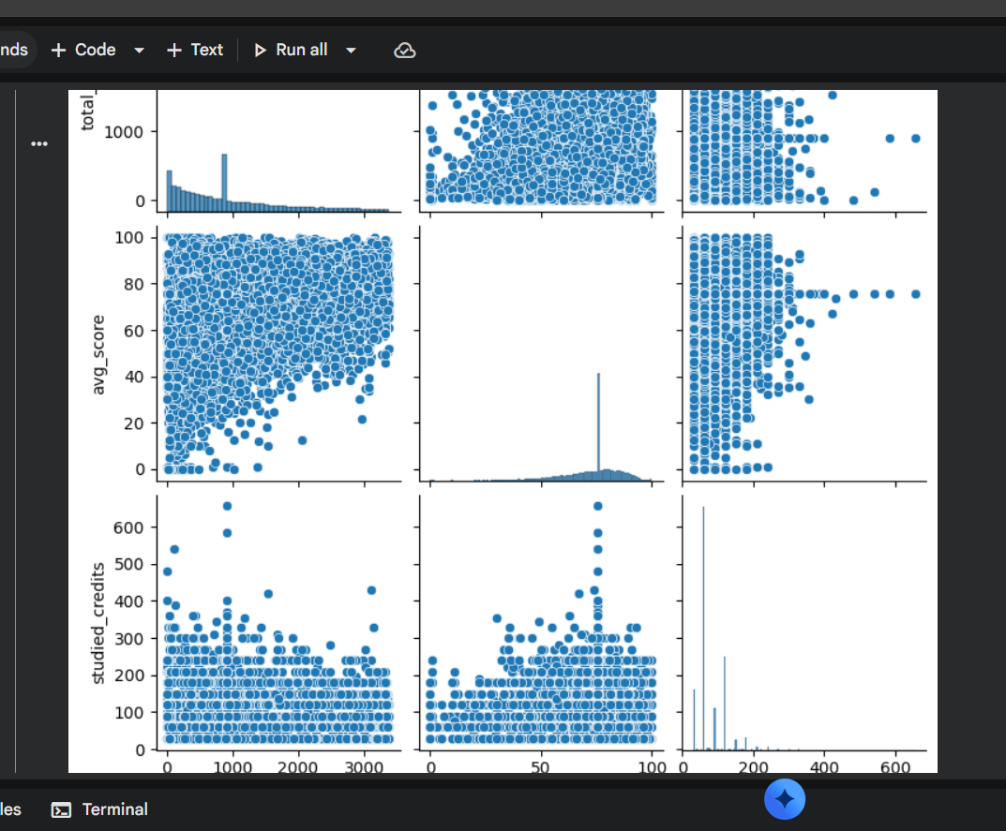
9. Visualizations Generated Using Power BI Dashboard
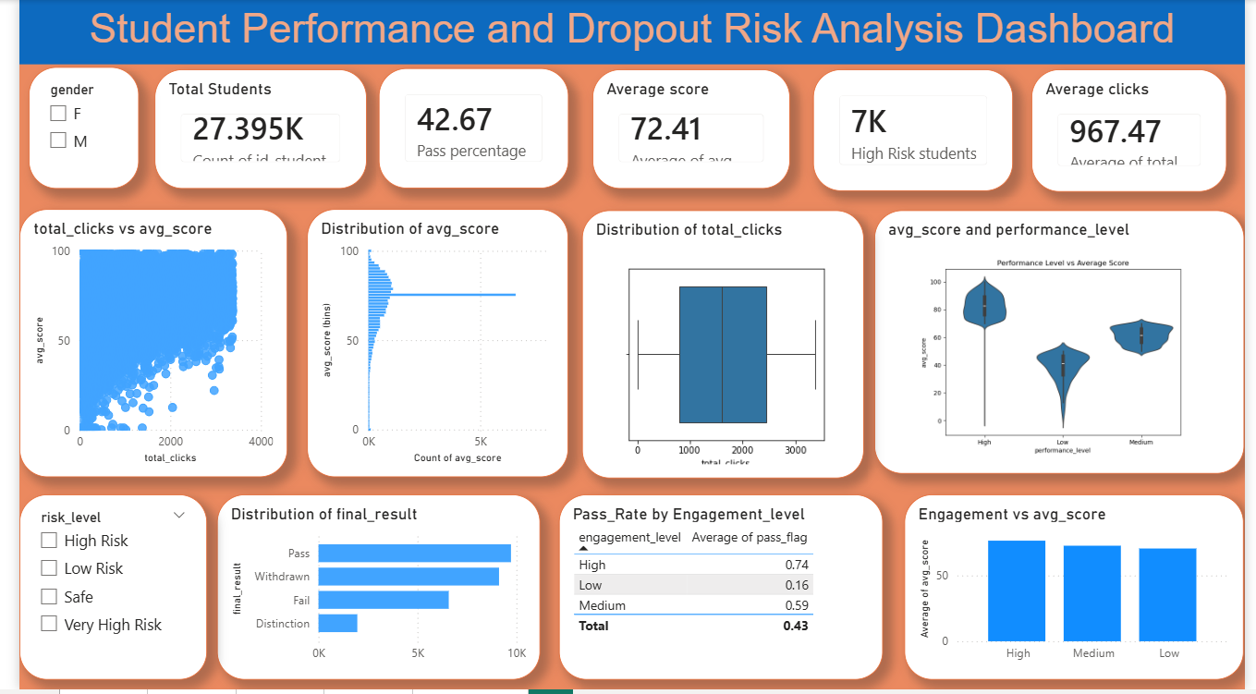
These visualizations help users easily analyse student performance and engagement.
9.1. Measures and Calculations
The following calculations and KPIs were created in Power BI:
KPI | Description
Total Students | Total number of students
Average Score | Average score of all students
Pass Percentage | Percentage of students passed
High Risk Students | Count of high-risk students
Average clicks average of total clicks
10. Results
Key Findings:
Parameter | Result / Insight
Student Engagement | Students with higher engagement generally score better
High Risk Students | Low engagement students are more likely to become high risk
Average Score | Most students fall under medium score range
Performance Distribution | Some students perform exceptionally high or low
Correlation Analysis | Positive relationship exists between clicks and scores
11. Analytical Observations
- Students with high engagement levels generally achieve higher academic scores.
- Low engagement students tend to fall under high-risk categories.
- Outliers indicate exceptionally high-performing students.
- Correlation heatmap shows positive relationships between engagement and performance.
- Interactive dashboard helps quickly identify student performance patterns.
The Power BI dashboard combines all findings into a single interactive analytical report.
12. Conclusion
This project successfully demonstrates the use of Python and Power BI for educational data analytics. The dataset was explored, cleaned, analysed, and visualized to identify student performance trends and engagement patterns.
Python played a major role in preprocessing, exploratory data analysis, and visualization generation, while Power BI was used for advanced dashboard creation and interactive reporting.
The project helps identify high-risk students, analyse engagement behaviour, and support academic decision-making using data-driven insights.
Overall, the project demonstrates practical skills in:
- Data preprocessing
- Exploratory Data Analysis
- Data visualization
- Dashboard development
- Business intelligence reporting
This project showcases analytical thinking and technical skills suitable for real-world data analyst and business intelligence roles.

